

The Republic of Uganda

MAYUGE DISTRICT LOCAL GOVERNMENT
P.O.BOX 1317
MAYUGE

DRAFT CLIENT CHARTER FOR FY
2025/26-2029/30

TABLE OF CONTENT
FOREWORD 4
PREAMBLE 6
CHAPTER ONE: INTRODUCTION 8
1.0 INTRODUCTION: 8
1.1 Mandate: 9
1.2 Vision: 9
1.3 Mission: 10
1.4 Goal 10
1.5 CORE VALUES OF MAYUGE DISTRICT 10
CHAPTER TWO: PRINCIPAL SERVICES AND COMMITMENTS 11
2.1 PRINCIPAL SERVICES 11
2.2 COMMITMENTS 19
CHAPTER THREE: GENERAL STANDARDS 23
3.1 EXPERIENCE THE CUSTOMER IS EXPECTED TO HAVE WITH THAT PARTICULAR DEPARTMENT, UNIT AND LOWER LOCAL GOVERNMENT 23
3.1.1 Working Hours. 23
3.1.2 Quality of services: - 23
3.3 GENERAL EXPERIENCE THE CLIENT IS EXPECTED TO HAVE WITH THE DEPARTMENT, UNIT AND LOWER LOCL GOVERNMENT 24
CHAPTER FOUR: CLIENTS 25
4.1 OUR CLIENTS 25
4.2 CLIENT’S RIGHTS: 25
4.3 CLIENT’S OBLIGATIONS AND CONDITIONS. 25
CHAPTER FIVE: FEEDBACK MECHANISMS AND COMPLAINTS HANDLING 27
5.1 FEED BACK MECHANISM: 27
5.2 MECHANISMS OF MANAGING COMPLAITS AND APPEALS CHANNEL: 27
CHAPTER SIX: DISSEMINATION AND IMPLEMENTATION OF THE CLIENT CHARTER 30
6.1 CHANNELS FOR DISEMINATING THE CLIENT CHARTER 30
6.2 CLIENT CHARTER AND ACCOUNTABILITY MECHANISM IMPLEMENTATION 30
6.2.1PERFORMANCE ACCOUNTABILITY MECHANISM 30

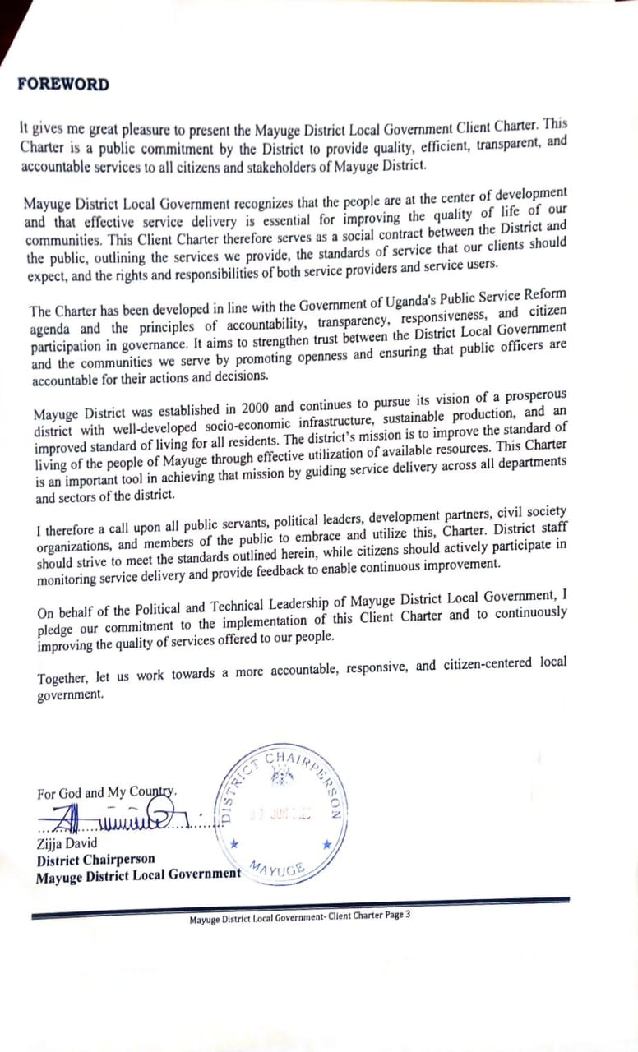
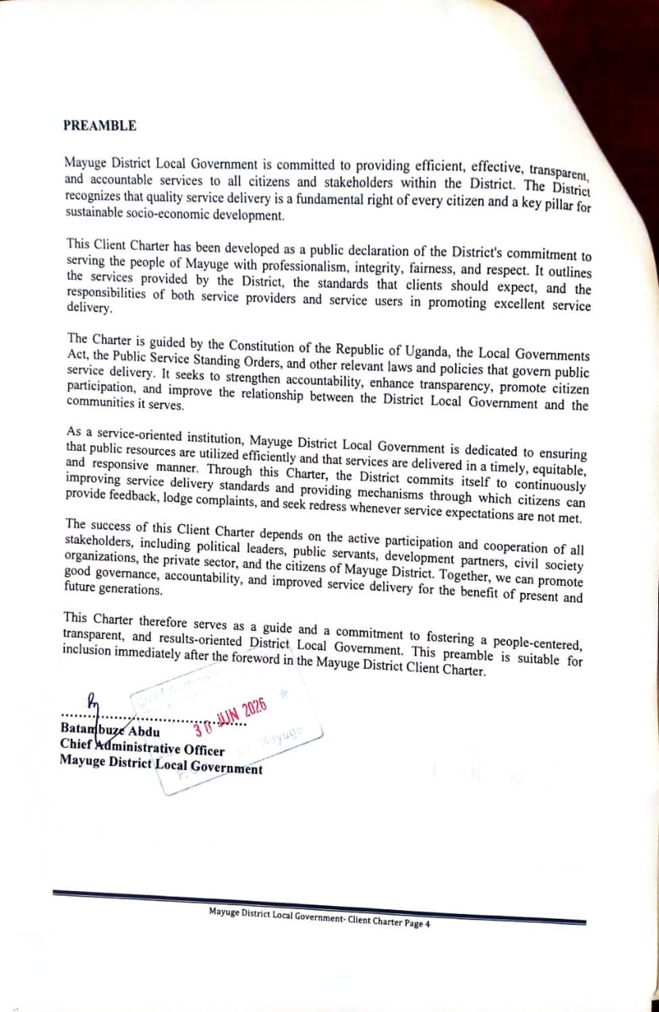

CHAPTER ONE: INTRODUCTION

1.0 INTRODUCTION:
Mayuge District Local Government has prepared this charter based on the District Mandate, Vision, Mission and Values.
Mayuge District is located in Eastern Uganda within the Busoga Sub-Region, lying within the Lake Victoria basin and stretching approximately between latitudes 0–1 degrees North and longitudes 33–34 degrees East. The District is bordered by Iganga District to the north, Jinja District to the west, Bugiri District to the east, and Lake Victoria to the south, whose waters are shared with Buikwe, Namayingo and Jinja Districts.
Mayuge District Local Government derives its mandate from the Constitution of the Republic of Uganda, 1995 (as amended), the Local Governments Act, Cap. 243, the Public Finance Management Act, 2015 (as amended), the Public Service Standing Orders, the Public Procurement and Disposal of Public Assets Act, and other relevant laws, regulations, and Government policies governing local governments.
In accordance with Uganda’s decentralization policy, the District is mandated to provide effective, efficient, accountable, and equitable public services to the people of Mayuge. The District exercises political, administrative, planning, legislative, budgeting, regulatory, and supervisory functions aimed at promoting sustainable socio-economic development and improving the quality of life of its citizens.
Specifically, Mayuge District Local Government is responsible for Preparing and implementing district development plans and budgets, Delivering quality public services in sectors such as education, health, agriculture, water and sanitation, roads, community development, natural resources, and environmental management, Promoting local economic development and sustainable utilization of natural resources, Mobilizing and managing public resources in a transparent and accountable manner, Coordinating and supervising Lower Local Governments and government programmes, Promoting good governance, the rule of law, public participation, transparency, accountability, and protection of human rights in the District.
Through this mandate, Mayuge District Local Government is committed to delivering quality services that are responsive to the needs and aspirations of the people in accordance with national laws, policies, and development priorities.
The District headquarters are located in Mayuge Town Council, approximately 40 km from Jinja City, about 120 km from Kampala, and within close proximity to major regional trade and service centres in Eastern Uganda. Mayuge District lies within the Jinja–Busoga–Lake Victoria economic corridor, giving it strategic importance for fisheries, agriculture, trade, lake transport, tourism, and agro-based industrial development. The southern boundary of the District is defined by Lake Victoria, and the District also includes island communities under Jaguzi Sub-county, further strengthening its strategic role in Uganda’s lakeshore economy.

While this strategic location presents major opportunities in fisheries, aquaculture, agriculture, tourism, trade, and cross-district commerce, it also exposes the District to flooding, lakeshore erosion, wetland degradation, deforestation, pollution of Lake Victoria, and climate-related risks. These challenges have significant implications for physical planning, settlement development, infrastructure investment, environmental management, and disaster risk reduction during the LGDP IV period.

1.1 Mandate:
Our mandate is to administer and develop Local Government Administrations as per the provisions of Article 176(1) of the Constitution of the Republic of Uganda 1995 (as amended) and the Local Government Act cap 243 (as amended) in view of improving service delivery in the district.

1.2 Vision:
The district vision is to have a Prosperous District with developed social economic infrastructure, vibrant private sector, sustainable production and productivity and people enjoying a high standard of living”.

1.3 Mission:
“To improve the standard of living of people of Mayuge using the available resources efficiently”.

1.4 Goal
To strengthen the decentralized service system to facilitate access to essential and basic services by the community.

1.5 CORE VALUES OF MAYUGE DISTRICT

Integrity: We shall be honest as much as possible while conducting public affairs.

Selflessness: We shall act solely in terms of public interest without consideration for any personal benefit or gain.

Transparency & accountability: We shall be transparent and accountable for our decisions and actions to the clients in the event of execution of our duties and submit ourselves to appropriate scrutiny to that effect.

Loyalty: We shall be committed to government policies and programs at both national and local levels.

Impartiality: We shall give fair and unbiased treatment to all clients irrespective of gender, religion, race, ability or ethnic background. We shall make choices based on merit.

Mandate: Mayuge District Local Government derives her mandate from Article 176 of the 1995 Constitution of the Republic of Uganda and the Local Government Act Cap 138 with its amendments

CHAPTER TWO: PRINCIPAL SERVICES AND COMMITMENTS
This chapter specifies the services offered by Mayuge district local government, categorizes the services that are Offred at the cost and those that are not charged, highlights the costs where applicable, Describes the process of accessing the services and specifies the service delivery points.

2.1 PRINCIPAL SERVICES
Service | Minimum access time | Procedure/requirement to access the service | Fees (if any)
Improve welfare of the people through increased sustainable production and marketing. |  | We shall: -  - Provide extension services to all farmers annually.  - Sensitize the communities on income generating activities annually.  - Procure and distribute improved and disease resistant planting materials and stocks to 2500 farmers for multiplication in the district by 2024.  - Procure and deploy 380 Tsetse flies traps in the Tsetse flies infested sub counties throughout the district.  - Promote Commercial agriculture through training of 150 farmers groups annually.  - Train 1200 farmers in enterprise identification, selection and management annually.  - Ensure that each sub county has one functional saving and credit cooperative organization. (SACCO)
An efficient health service delivery system developed and access to information on cross cutting issues improved. |  | We shall: -  - Promote elimination of mother to child transmission of HIV/AIDS [PMTCT] by enrolling all expectant mothers tested HIV/Aids positive during Antenatal services.  - Sensitize communities on health and sanitation and provide health education once every quarter in each constituency.  - Conduct HIV/AIDS prevention campaigns in each constituency once every two months.  - Inspect public sanitation facilities to ensure that they conform to the national standards at least once every month.  - Assist at least 3 needy patients to access surgical services annually.  - Construct at least 5 staff houses for health workers at health centre IIs, IIIs and IVs by 2029
Basic education for all provided and equitable development of talents promoted. |  | We shall: -  - Inspect all the 142 primary schools and all post primary institutions in the District at least once a term.  - Reduce pupil desk ratio from 1:5 to 1:3 by 2024  - Enforce co-curricular activities in 90%of all the government aided and private schools in the district.  - Increase the number of Government Aided vocational institutions from one to two in the next five years.  - Improve sanitation and hygiene in school institutions by;  - Constructing at least 25 lined pit latrine stances annually.  - Promotion of hand washing in all schools.
Efficient road network provided. |  | We shall: -  - Review and approve building plans within 3months from the date of receipt of application.  - Inspect building projects for each of the following 4 stages. (i)Commencement of work  (ii)Foundation  (iii)Walling/superstructure  (iv)Roofing  - Rehabilitate and maintain 20% of community roads opened by the district and lower local government annually.  - Upgrade 15% of community roads to feeder roads status within five years.  - Promote equity in the distribution of infrastructure in the district
Safe water provided and good sanitation practices promoted. |  | We shall; -  - Reduce the water distance to safe water points from the current 1.5 to 1km in the next five years.  - Conduct sensitization meetings for committees to increase improved latrine coverage to at least 80% through establishing sanitation committees in every sub county annually.  - Establish at least 40 water user committees to ensure community based management system functions annually.  - Enact and enforce bye-laws on hygiene and sanitation in the District by 2022.  - Provide public toilets in 5 rural growth centers and the two town councils by the end of 2023.  - Conduct water testing to ensure use of clean water for at least 300 water sources annually  - Provide safe clean water to 10% of the schools and other institutions through drilling and installing 40 bore holes.  - Rehabilitate and repair 20 boreholes annually.
Service delivery by empowering communities to manage and exploit available resources effectively improved. |  | We shall: -  - Respond to all correspondences within 5 days on the date of receipt.  - Conduct at least 5 capacity building training modules every financial year.  - Conduct induction trainings for every newly recruited staff two weeks after assumption of duty.  - Confirm staffs within 3 months after the six months probation.  - Implement all lawful ordinances and resolutions by the district council resolutions within 2 months.  - Ensure safety and protection of all staff in the district.
Capacity at all levels to deliver services to the people efficiently and effectively developed (Human resources managed). |  | We shall: -  - Declare vacant posts in the structure for filling within 3o days upon receipt of relevant documents.  - Prepare and submit pay change reports for processing of salaries to the ministry of public service by 16th of every month.  - Coordinate the completion of performance agreements/reports and staff appraisals by 31st July of every year.  - Coordinate human resource development and training every year.  - Submit disciplinary returns to the ministry quarterly
Utilization of natural resources for sustainable development rationalised. |  | We shall: -  - Create awareness on sustainable use of wetlands in all parishes of at least two sub counties and form parish wetland management committees annually.  - Sensitize communities on agro forestry quarterly.  - Formulate community-based wetland management plans for all wetlands.  - Monitor the existing community-based wetland management plans and sensitize community on wetland issues on a quarterly basis.  - Increase survey control points coverage from15% to 35% by 2024.  - Increase community legal land ownership from 20%to 45% by 2024.  - Sensitize at least 30%of registered forestry resource dealers per year on sustainable use of forestry resources by 2024.  - Conserve the ecological areas throughout the district annually.  - Have functional physical planning committees in place by 2022.  - Emphasis on climate change awareness in all lower local governments annually.
Welfare of the OVC and PWDs improved and livelihood in the community enhanced. |  | We shall: -  - Conduct community training services for the youth, women, PWDs and elderly persons at least once every 3months.  - Approve operations of community-based organizations within a period of one month upon application and submission of required documents.  - Handle all cases under labor, probation and children welfare within 4 working days. Welfare of the OVC and PWDs improved and livelihood in the community enhanced.  - We shall:  - Conduct community training services for the youth, women, PWDs and elderly persons at least once every 3months.  - Approve operations of community-based organizations within a period of one month upon application and submission of required documents.  - Handle all cases under labor, probation and children welfare within 4 working days.
Ensuring timely accountably and upholding of financial regulations (Finance and Administration, Financial management, procurement and internal controls carried). |  | We shall; -  - Each department is obliged to prepare a departmental performance plan, account and maintain actual performance record deliveries on a quarterly basis.  - Pay salaries for all staff by 28th of every month.  - Attend to our clients within 30 minutes of arrival of service delivery.  - Ensure that all statutory meetings of councils take place at prescribed intervals, are open to the public and minutes of all meetings are made public in two weeks in accordance with the provisions of the law.  - Ensure that the staffs work as per target and schedules of duties as required by the provisions of the standing orders and standing regulations and guidelines.  - Provide performance accountability reports to council on an annual basis in line with the provisions of the law.
All government recognized institutions at all levels functional. (Participatory development enhanced) |  | We shall; -  - Involve all stakeholders in the planning process of the district.  - Plan for, budget and implement only those investments that have gone through a bottom-up participatory planning process.  - Adequately budget for national and district programs.  - Mainstream gender issues in all development plan for the district and lower local governments.

2.2 COMMITMENTS
We are committed to uphold the mandate, Mission and Vision by rendering services and we undertake to be guided by the following Commitments and principles as we serve our clients.
SN | Cross cutting area | Commitment to clients
 | Client Focus and Customer Care; | We shall always give fair treatment to our clients being prompt and polite as the lead priority, by making every possible effort to meet their requirements and expectations with in our mandate and established standards.
 | Objectivity | Decisions taken by the district and her staff shall be neutral while professional in nature, based on merit irrespective of status, sex and gender, the Code of Conduct and Ethics of the public service and other Codes of best practices.
 | Integrity | We shall observe absolute honesty in all official acts. This shall extend beyond financial considerations to include unmerited advantage of any kind of person, family or friends. Corruption shall not be tolerated all our interactions.
 | Credibility | We shall be credible and trustworthy in our operations and we shall guard against being disciplined in the service, complete in-service delivery, putting our clients’ interests before own interests and we shall always demonstrate a high degree of professionalization and loyalty to government.
 | Transparency and Accountability in the course of providing services | We shall be as open as possible in all the decisions made at the respective levels, communicating them to all the respective beneficiaries timely and appropriately, transparent and accountable for our decisions and actions to the Clients and submit ourselves to appropriate scrutiny.
 | Efficiency and Effectiveness in service delivery | We shall strive for optional utilization of our resources to achieve maximum outputs in relation to the targets and performance standards set within the available resources in all our operations and transactions and in timely manner
 | Partnership | We shall involve our clients in designing, implementing, monitoring and evaluating our programs.
 | Continuous improvement | Work in collaboration with our clients, partners in order to continuously improve the quality of services we provide, for the ultimate benefit of our clients.
 | Loyalty | We shall be committed to government policies and programmes both at National and Local levels.
 | Responsiveness | We shall be conscious of clients’ needs and we shall attend to their requests, suggestions and criticisms timely in an actively manner.
 | Openness and information sharing | We shall be open and communicate clearly and effectively in simple language in order to help people using our documents conceptualize all information. We shall also provide to our clients relevant information related to service delivery on a quarterly and annual basis within provisions of the law.
 | Accountability | We shall manage resources of the district by holding individuals personally responsible and accountable for their official actions or inactions.
 | Ethics and Integrity | We shall uphold the ethical code of conduct and integrity in handling all the clients and stakeholder by:  - Not seeking, accepting or offering gifts, favours or inducements, financial or otherwise in the course of discharging our duties.  - Not using public property or official time for our own private gains  - Not using information acquired in the course of our duties to gain personal financial advantage.  - Being honest and open in the course of discharging our duties.
 | Professionalism | We shall abide by the defined rules, regulations and guidelines of the respective offices, exhibiting competence and honesty. We shall abide by the defined rules, regulations and guidelines of the respective offices, exhibiting competence and honesty.
 | Timeliness | we shall observe time management in all our activities. Decisions will be made in the minimum possible timelines and commit to meet deadlines.
 | Diligence on duty | Be at our work places on and in time, devote ourselves wholly to work during official working hours and be careful and tireless in carrying out our official duties.
 | Courteous | Maintain a courteous and cooperative relationship with clients and colleagues. We shall regard ourselves as servants of people of Uganda and we shall particularly be considerate when dealing with the venerable members of the public, such as the elderly, the sick, youth and those with disabilities. We shall at all times dress appropriately, appear decent, respectable, friendly and helpful.
 | Professionalism | We shall abide by the defined rules, regulations and guidelines of the respective offices, exhibiting competence and honesty
 | Accountability | We shall manage resources of the district by holding individuals personally responsible and accountable for their official actions or inactions.

CHAPTER THREE: GENERAL STANDARDS
This chapter defines the experience the client is expected to have with that particular department, unit and t lower local government. These include:
- Hard customer defined service standards- which can be counted e.g. services accessed within 48 working hours, 2 working days, etc. shall treat our clients with courtesy, respect, integrity etc.
-Soft customer defined service standards- which are option based and cannot be counted. e.g we shall treat our clients with courtesy, respect, integrity etc.
-The general standards shall capture: -
(a) standards on attendance to duty, time management, general conduct and obligations of the public officers.
(b) standards on how and when to access the public officers
(c)standards on how services will generally be accessed
(d) standards in Clients management

3.1 EXPERIENCE THE CUSTOMER IS EXPECTED TO HAVE WITH THAT PARTICULAR DEPARTMENT, UNIT AND LOWER LOCAL GOVERNMENT

HARD CUSTOMER DEFINED SERVICES:

3.1.1 Working Hours.
Our clients should expect to be served considerately as follows:
- Days: Monday- Friday (Except on designated public holidays)
- Time: 8:00a.m – 12: 00P.m (Morning session)
- 2: 00p.m-5: 00p.m (afternoon session).

SOFT CUSTOMER DEFINED STANDARDS:

3.1.2 Quality of services: -
We will attempt to continuously improve the quality-of-service provision with regard to the following generation standards: -
- Acknowledge receipt of all correspondences within 5 Minutes at registry.
- Respond to all received correspondences within 2- 14 working days.
- Attend to all our clients within 30 minutes of arrival at the wok place
- Produce field reports and disseminate them to relevant clients within one month of completion of activity.
- Effect payments for services provided within 3 weeks after submission of all relevant documents.
- We shall treat our clients with courtesy, respect, dignity, etc

3.3 GENERAL EXPERIENCE THE CLIENT IS EXPECTED TO HAVE WITH THE DEPARTMENT, UNIT AND LOWER LOCL GOVERNMENT
In a bid to fulfill our mandate, Vision and Mission, we commit ourselves to the following: -
- Clients shall be attended to within 30 minutes of arrival at the respective service point
- Response to complaints and appeals will be two days on receipt of complaint and fourteen days for the appeal.
- Disseminate the client charter through DTPC meetings, departmental field activity meetings etc at the village, parish, and Sub County every financial year.
- Put in place feedback mechanism through; - Notice board, Suggestion boxes opened every week, meetings.
- Offices, schools, health facilities and other government facilities will be opened by 8.00am every day and close at 5.00pm as official working hours.
- Official correspondences will be responded to within two days upon receipt.

CHAPTER FOUR: CLIENTS

4.1 OUR CLIENTS
Our clients shall include;
Internal clients’ mainly the Staff, Political leaders and development partners present in the district. And external clients in particular the Central Government, Ministries, Agencies, Investors, NGO, CBO’s, SCO’s Institutions both government and private, the community of Mayuge, business community, the Public at large and they have a right to the following.

4.2 CLIENT’S RIGHTS:
Our clients shall have the rights to;
- Access quality service delivery at all levels.
- Information in line with the law.
- Participation in project identification and implementation.
- Equitable allocation of resources.
- Lodge complaints
- Participation and involvement in planning, Budgeting and implementation of development activities
- Feedback on implemented activities
- Privacy and confidentiality
- Timely responses to issues raised
- Technical guidance and advice
- Access to information, regular reporting and accountability within the prescribed law
- Demand for quality services and accountability from their leaders
- Treatment with courtesy, dignity, honesty etc.

4.3 CLIENT’S OBLIGATIONS AND CONDITIONS.
Our clients shall have the following obligations and conditions fulfilled in order to access our services: -
  - Demand for services while exhibiting a sense of honest in services consumption and complaints.
  - Comply with the laws, regulation, policies and guidelines
  - Check and report any faults regarding the services provided and give feedback.
  - Participate in the implementation of development work plan/budgets
  - Ensure local resources received are efficiently and effectively used in line with the approved budget and work plans.
  - Identify and prioritize community needs and Maintain up-to-date information for their projects
  - Expression of opinion during service delivery
  - Provision of required documents and relevant information to support service delivery requirements.
  - Maintain a clean and healthy environment.
  - Participation in development programmes and Engage in participatory planning process.
  - Provide correct and timely information as required by the District
  - Provide goods and services that conform to set standards.
  - Maintain peace, security, law and order.
  - Participate in the bottom up planning and budgeting process.
  - Maintain a clean and healthy environment
  - Raise community contributions in development programmes
  - Cooperate with service providers
  - Treat all our staff with courtesy
  - should comply with payable services

CHAPTER FIVE: FEEDBACK MECHANISMS AND COMPLAINTS HANDLING

5.1 FEED BACK MECHANISM:
Feedback is very important; it helps the district perform to client’s expectations by improving on service delivery, reviewing past performance while planning for the future. Therefore, facilitating evaluation of services rendered through the structure of the lower local councils to the district level is critical.

We encourage our clients to provide feedback on all interventions and services provided in their areas through the following ways:-

- Use of suggestion boxes at every service delivery point.
- Internal Memo
- Interaction with clients through meetings, workshops and seminars conducted by the district.
- Raising issues in writing to respective persons such that follow up is made easy.
- Use of telephone, contact CAO and service providers (District)
- Writing to the Chief Administrative Officer
- Use of E-mail (mayugedistrict@gmail.com.)
- Use of the website (www.mayuge.go.ug).
- Use of client feedback forms (will be made available at the reception.
- Inform clients on the status of remedial action being taken within 5(five) working days
- Produce monthly reports on complaints received and the remedial action taken

5.2 MECHANISMS OF MANAGING COMPLAITS AND APPEALS CHANNEL:
In case you feel unfairly served or treated you have a right to complain or express grievance through;
- Formal Written submission
- In-person reporting
- Drop suggestion boxes
- Email
- Grievance handling management committee handbook
Grievance handling mechanisms are the procedures and systems an organization uses to receive, investigate, resolve, and monitor complaints or concerns raised by clients, employees, or other stakeholders. In the context of a district local government such as Mayuge District, effective grievance handling promotes transparency, accountability, and public trust.
Grievance Handling Mechanisms include
1. Receiving Complaints
Complaints may be submitted in person, by telephone, email, suggestion boxes, letters, or through online platforms where available.
Complaints should be acknowledged promptly and recorded in a grievance register.
2. Registration and Documentation
Each complaint is assigned a reference number. Essential details such as the complainant's name (where provided), contact information, nature of the complaint, date received, and supporting evidence are documented.
3. Assessment and Classification. The complaint is reviewed to determine its nature, urgency, and the responsible department. Urgent matters are prioritized for immediate action.
4. Investigation
The responsible officer gathers facts, interviews relevant parties, reviews documents, and determines the validity of the complaint. Investigations should be impartial, confidential, and conducted within established timelines.
5. Resolution
Appropriate corrective action is taken based on the investigation findings.
Possible resolutions include providing information, correcting administrative errors, disciplinary action where necessary, compensation where applicable, or improving service delivery.
6. Communication of the Outcome
The complainant is informed of the findings and the action taken within the prescribed timeframe. Reasons should be provided where a complaint cannot be upheld.
7. Appeal or Review
If dissatisfied, the complainant should have the right to request a review or appeal to a higher authority within the organization. Unresolved grievances may be referred to relevant oversight institutions.
8. Monitoring and Feedback
The organization monitors implementation of agreed actions and seeks feedback from complainants. Lessons learned are used to improve policies and service delivery.
9. Record Keeping and Reporting
All grievances and their resolutions are securely documented. Periodic reports are prepared to identify recurring issues and recommend improvements.
5.3 DIFFERENT LEVELS IN COMPLAINT HANDLING MECHANISM
- Contact the action officer first, by arising it with the person rendering a service through these interactive answers will be provided.
- When the client is not satisfied with the response provided by the officer who rendered the service, he or she should raise the issue with the relevant supervisor, within three days. channels
- Failure to have a response from the supervisor, an appeal be raised to the Head of Department, the officer at this level should be able to resolve the complaint within five days.
- If the client is not satisfied with the response given, he or she can lastly raise it with the Chief Administrative Officer, giving this office fourteen working days from the time of receipt of the written communication.
- Failure by the Chief Administrative Officer to resolve the complaint / appeal, he/she should forward the case to the Secretary Grievance handling committee who will register the case in the Complaint book,
- Clients can also raise complaints where they have not been adequately handled or addressed, with the office of the Inspector General of Government or forward their complaints to the courts of law.

CHAPTER SIX: DISSEMINATION AND IMPLEMENTATION OF THE CLIENT CHARTER

6.1 CHANNELS FOR DISEMINATING THE CLIENT CHARTER
The charter will be disseminated through the following channels
- Displaying it on the District Main Notice Boards.
- District Website.
- stakeholder’s meetings.
- distributed to all Lower Local Councils in the District.
- Digital and social media platforms
- Direct handout

6.2 CLIENT CHARTER AND ACCOUNTABILITY MECHANISM IMPLEMENTATION
the client charter and accountability mechanism shall be implemented through performance accountability, performance improvement, promotion of the service clients’ charter and the lower local governments client charter as below: -

6.2.1PERFORMANCE ACCOUNTABILITY MECHANISM
The District has an obligation to report back to clients on its performance. We pledge to remain accountable to all our clients for our actions and inactions in the following ways;
- Publish information on service rendered on the respective District notice boards and sub-county notice boards.
- We shall undertake to produce annual reports, on the implementation of the client charter for each financial year arrange Annual Seminars involving all stakeholders and budget conference.
- We shall regularly arrange meetings, and client round table discussions at least once a year.
- The District will report on its performance through the mass media like radios, televisions, newspapers and annual Baraza meeting at the District Headquarters.
- The implementation of this charter will be reviewed annually to assess progress and further improvement on service delivery. Other means will include; Quarterly and Annual Performance Reports.

CONTACT US THROUGH THE FOLLOWING;
Physical Address:
MAYUGE DISTRICT LOCAL GOVERNMENT
P.O. BOX 1317
MAYUGE
E-mail: (mayugedistrict2000@gmail.com)

Website: www.mayuge.go.ug.

Batambuze Abdu
Chief Administrative Officer:

Compiled by:

Wakirwaine Damalie
Principal Personnel Officer
(Client Charter Focal Person)

Kigada Marriam
Human Resource Officer
(Client Charter Focal Person)

Published by:
Nankoma Jackline
(Senior Communication Officer)

Madambo Bashir
(Communication Officer)

FOR GOD AND MY COUNTRY

